**TITLE OF LAB: (INTRODUCTION TO TRANSISTORS)**

**Lab No. #08**



**Spring 2022**

**CSE-206L Electronic Circuits Lab**

Submitted by

**Safi Ullah Khan : 20PWCSE1943**

Class Section: **B**

“On my honor, as student of University of Engineering and Technology, I have neither given nor received unauthorized assistance on this academic work.”

Student Signature: ______________

Submitted to:

**Engr. Abdullah Hamid**

(Monday, June 19th, 2022)

**Department of Computer Systems Engineering**

**University of Engineering and Technology, Peshawar**

**Objectives:**

* To determine transistor type (NPN, PNP), terminals and material using Digital multimeter.
* To determine the values of the alpha and beta ratios of transistors.

**Equipment:**

* DC voltmeter
* DC Ammeter
* DC Power Supplies

**Components**:

* Resistors: 1 k, 330 k, 10 k
* potentiometer, 1M potentiometer
* Transistors: 2N3904

**Transistor:**

* It is an electronic device which work on small voltage and consume very little power.
* It is an electronic device made from two PN junction Diodes one is called emitter-base junction other one is called collector-base junction.
* The transistor is a semiconductor which transfers a weak signal from low resistance circuit to high resistance circuit.
* It is used as amplifier and switch.
* It has three terminals namely emitter, base and collector.

**Circuit Diagram:**

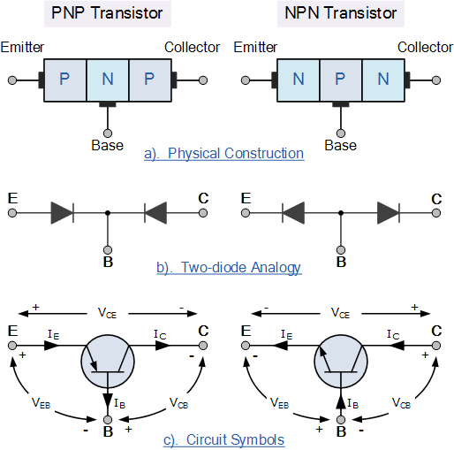

**Transistor Terminals:**

* Transistors comprise of three sections of doped semiconductors. The portion on one side is the emitter and the portion on the opposite side is the collector. The Middle portion is known as the base which forms two junctions between the emitter and the collector as shown in the figure. These 3 are explained below in detail.

1. **Emitter:**

* It is a heavily doped terminal through which electrons enter.  It is always forward biased w.r.t. base in biasing so that it can supply a large number of majority carriers. As shown in the figure above, the emitter of PNP transistor (right side figure) is forward biased and supplies hole charges to its junction with the base while the emitter of NPN transistor (left side figure) supplies electron charges to its junction.

1. **Base:**

* It is lightly doped terminal through which electrons pass from the emitter to collector. The base-emitter junction is forward biased and allows low resistance to the emitter circuit while the base-collector junction is reverse biased and provides high resistance in the collector circuit. The Depletion layer is formed in the base junction of the transistor.

1. **Collector:**

* It is a moderately doped terminal which basically collects electron. The collector is always reverse biased in biasing and its function is to remove charges from its junction with the base. As shown in the figure above, the collector of the PNP transistor is reverse biased and receives holes charges that flow in the outer circuit while the collector of NPN transistor receives electron charges.

**Types of Transistors:**

**Two types of transistors:**

1. **Bi-junction Transistor:**

* Those transistors whose functionality depends upon both majority and minority charge carrier.

1. **Uni-junction Transistor:**

* Those transistors whose functionality depends upon only majority charge carrier.

We will study only Bi-junction Transistor.

There are two types of Bi-junction Transistor.

1. **NPN transistor:**
2. **PNP transistor:**
3. **NPN transistor:**

* A transistor in which P-type material is sand witched between two N-type materials.

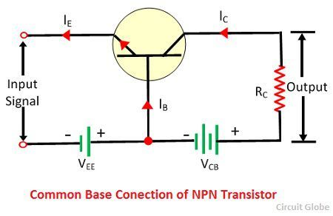

**NOTE:**

* In NPN-transistor current is due to negative charger carrier electrons.
* Electron move from emitter to base. As collector is reverse biased but VCB is connected which attract electrons from base.
* VCB is always greater than VEB because more energy is required to attract electron from base to collector which Is reverse biased.
* The above direction of current is conventional current actually but here actually current is due to electrons so all IE, IC and IB are reverse in direction.
* In NPN transistor,

**IE = IB + IC**

1. **PNP Transistor:**

* A transistor in which N-type material is sand witched between two P-type materials.

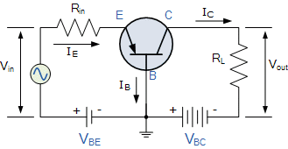

**NOTE:**

* In PNP-transistor current is due to Positive charger carrier holes.
* Holes move from emitter to base. As collector is reverse biased but VCB is connected which attract electrons from base.
* VCB is always greater than VEB because more energy is required to attract electron from base to collector which Is reverse biased.
* The above direction of current is correct b/c here current is conventional current and direction is also conventional.
* In PNP transistor also,

**IE = IB + IC**

**NOTE:**

* We study and used only NPN transistor because in NPN transistor the Mobility of electrons is 3- Time faster than Holes in PNP transistor.

**Our Aim in this lab is to determine the values of the alpha and beta ratios of transistors:**

**Procedure:**

Construct the circuit of *Fig.1*. Vary the 1M ohm potentiometer to set IB and VRB to Required given values as in Table.

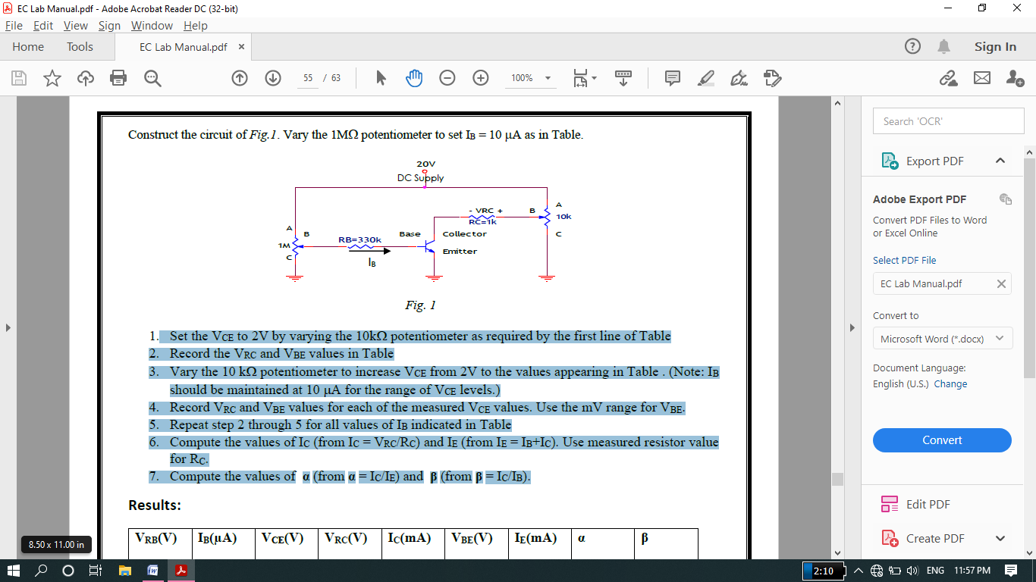

* Calculate VCE=(Vcc-VRC)
* Record the VRC and VBE values in Table
* Record VRC and VBE values for each of the measured VCE values.
* Repeat step 2 through 5 for all values of IB indicated in Table
* Compute the values of IC (from IC = VRC/RC) and IE (from IE = IB+IC). Use measured resistor value for RC.
* Compute the values of **α** (from **α** = IC/IE) and **β** (from **β** = IC/IB).

**Proteus Schematic:**

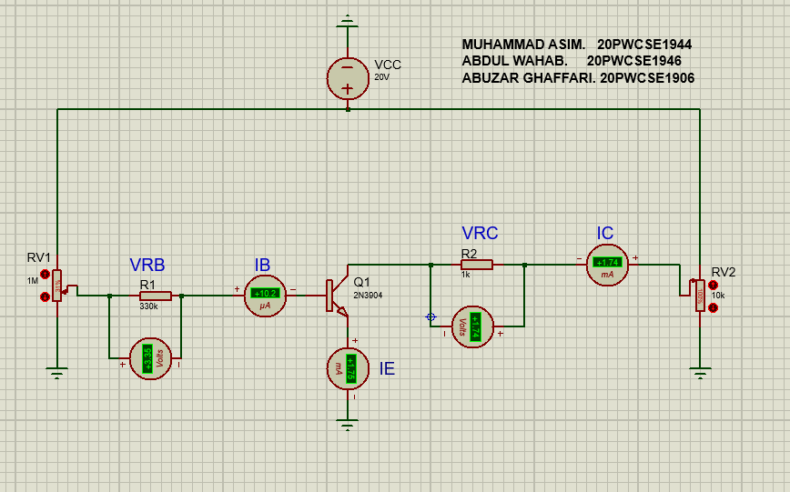

**Lab Picture:**

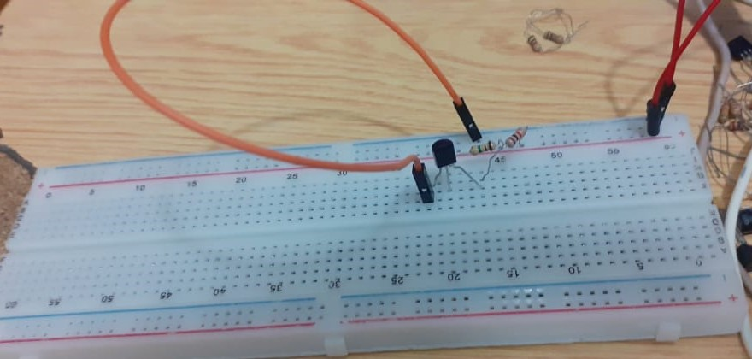

**Different Formulas:**

* **IB=VRB/RB=VCC-VBE/RB**
* **IC=VRC/RC=VCC-VCE/RC**
* **VCE=VCC-VRC**
* **VBE=VCC- VRB**
* **VRC=IC/RC**
* **VRB=IB/RB**
* **Alpha=IC/IE.**
* **Beta=IC/IB.**

**DATA TABLE:**

|  |  |  |  |  |  |  |  |  |
| --- | --- | --- | --- | --- | --- | --- | --- | --- |
| VRB(V) | IB(μA) | VCE(V) | VRC(V) | IC(mA) | VBE(V) | IE(mA) | α | β |
| 3.3 | 10 | 18.26 | 1.74 | 1.74 | 0.7V | 1.75 | 0.99 | 174 |
| 3.3 | 10 | 18.26 | 1.74 | 1.74 | 0.7V | 1.75 | 0.99 | 174 |
| 5.6 | 20 | 17.25 | 2.75 | 2.75 | 0.7V | 2.77 | 0.98 | 137 |
| 5.6 | 20 | 17.25 | 2.75 | 2.75 | 0.7V | 2.77 | 0.98 | 137 |
| 5.6 | 20 | 17.25 | 2.75 | 2.75 | 0.7V | 2.77 | 0.98 | 137 |
| 9.9 | 30 | 14.1 | 5.9 | 5 | 0.7V | 5.12 | 0.97 | 196 |
| 9.9 | 30 | 14.1 | 5.9 | 5 | 0.7V | 5.12 | 0.97 | 196 |
| 13.2 | 40 | 12.66 | 7.34 | 7.34 | 0.7V | 7.38 | 0.99 | 183 |
| 13.2 | 40 | 12.66 | 7.34 | 7.34 | 0.7V | 7.38 | 0.99 | 183 |
| 16.5 | 50 | 10.89 | 9.11 | 9.11 | 0.7v | 9.16 | 0.99 | 182 |

* VBE is the Knee voltage Silicon Diode in Transistor.
* VRC and IB already given, we have to fix these values in proteus using 1M potentiometer.
* We have record VRC, IE and IC in table from proteus.
* We have to calculate VCE=(Vcc-VRC).
* Finally find α=IC/IE, β=IC/IB.

**-----------------------------------THE END-----------------------------------**